EDU 550 – Assignment 1 i

Literacy and Numeracy In the Classroom – Assignment 1

Shena Anglin
Literacy and Numeracy In the Classroom EDU 550
Dr. M. Minott
December 11, 2009

EDU 550 – Assignment 1 1

Maps, charts, picture and Information Communication Technology (ICT) are important aids to the teacher. State FIVE ways in which each of these may serve a USEFUL PURPOSE. Explain how you would use effectively any ONE in a content area lesson of your choice.

A teaching aid is a tool which a teacher uses to help make her lesson more interesting, it can help to make knowledge more concrete in the minds of her students.
The uses of maps in the classroom are as varied as the types of maps themselves. I will begin by describing the different kinds of maps that there are, and will follow each one by discussing its uses. Then I will introduce the various forms of chart and follow with a discussion of their uses. I will then give an overview of the various uses for pictures in the classroom. Finally I will discuss the ways in which Information Communication Technology (ICT) can be used in education and how it has improved the way that we teach. All these alternatives to the traditional “chalk and talk” has enhanced the way that students learn as they serve as visual tools, especially for visual learners, but indeed help to make our lessons more interesting.
When we hear the word map we usually think of geographical maps, and this is the kind of map that I will open my paper with. There are various kinds of geographical maps that show different things depending on their purpose.
One type of geographical map is the World Map, also known as a World Atlas. This map shows all the countries of the world, including their size and relation to each other. The larger the scale
EDU 550 – Assignment 1 2
of the map, the more detail will be shown of course. The map of the world would be used in many different subject areas to show the location of the particular country or countries that are being discussed in the lesson at hand. A World Map can be utilized in a Social Studies lesson at the primary level to show the location of a particular country in relation to Cayman. A World Atlas can also be utilized in a Geography lesson at the secondary level to show where a country is located and its geographical features, as to whether it is bordered by oceans or an enclave of another country. Or such a map may also be used in an Economics lesson in comparing economies of different countries, and discussing geographical features of those countries that may affect those economies. A World Atlas may also be used in a History lesson to show how far ships used to travel around the coast of Africa from Europe, to get to India for spices in the spice trade.
Another type of map is an individual country map. These maps show a single country and depending on the scale, show a greater amount of detail. A map of Grand Cayman can show year two students where each district is located. This type of map would also be used in teaching lessons about the geographical features of a country, such as the strategic location of a city near to a river for example. Another use of a country map in teaching would be for students to be able to know the history of their country by identifying key places that important events took place.
There are also street maps which would show details of roads throughout a city so that students may learn to find their way around an unknown place. Topographical maps illustrate the lay of

EDU 550 – Assignment 1 3
the land and make it easier for students in a geography lesson to visualize how mountainous a particular country is as a whole.
Other kinds of maps include Thinking Maps, maps where we lay out ideas or concepts, and Mind Maps. A concept map is not only used as a learning tool but also as an evaluation tool. Concept maps can be used in finding both correct and incorrect ideas that our students may have and assessing the knowledge that our students acquire after a lesson. Mind maps are a useful way for students to map out on paper what they have learned or what they think about a particular subject. We can learn more about our students’ experiences in this way as well.
One kind of thinking map is known as the Circle Map. Circle Maps are a way that students can map out their thoughts on paper in an organized fashion so that it is easier for them to think of the subject and its related information. It is a handy visual tool that students can refer to for a summary of their information. For instance, students can map-out a story plot in the form of a Circle Map by placing the parts of the story equally around the circle and placing the various thoughts or ideas they have from the different parts of the story within each part on the circle. Circle Maps are best used for brainstorming or defining in context. This is illustrated in Figure 1. 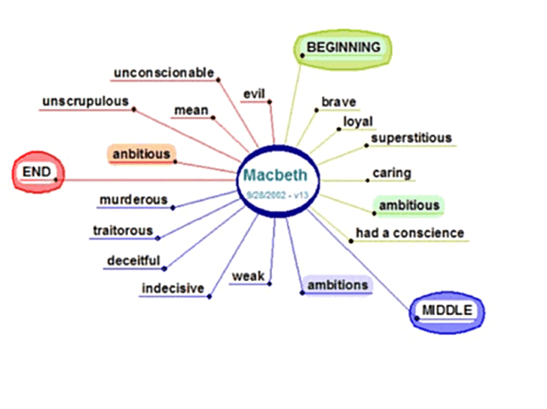
Figure 1
EDU 550 – Assignment 1 4
An Attributes Map places the main subject in a rectangular box in the centre and places the various attributes of the particular subject around the center.
Bubble Maps have one central bubble in which we place the subject we are mapping and various bubbles go around the bubble in the middle with several thoughts or ideas we may have on the subject.
There are also Concept Webs which we use to map-out concepts. This, figuratively speaking is a web of ideas regarding a particular topic. Each concept is a part of the web.
Another type of map is called a Tree Map. In this type of map we place the topic at the top of the tree and each underlying idea as a part of the root. We would use this kind map in organizing an essay or thesis. For example it is used in classifying or categorizing ideas.
A Flow Map shows the flow or sequence of a process. For instance we might show the sequence to solve a mathematics problem. There is one main task at the top and below it is the sequence of actions we would take in order to complete the process. This type of map may also be used to map-out the plot or sequence of a story that our students are going to write.
There are also Double Bubble Maps in which we compare two similar concepts. For instance we might compare the attributes of two different animals (mammals and birds) in a Biology lesson.
In a Multi-flow Map, ideas flow in multiple directions instead of just one direction. The main subject is at the center and the sub-ideas are placed in two or more different directions, depending on how similar the ideas are or what category they fall into. For instance we might

EDU 550 – Assignment 1 5
discuss the various causes of the global warming phenomenon in one direction and then the effects of global warming in the opposite direction.
A Brace Map is a map in which we analyze a particular whole and its component parts. For instance we might show the structure of an organization in a Business Studies course using a Brace Map.
A Bridge Map looks like a bridge and is used to compare a set of like things. In other words it is used in making analogies. Please see Figure 2.
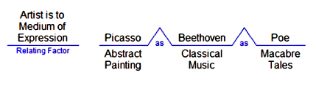
Figure 2

Mind Maps are a more complex form of Bubble Map. The main idea is placed in the middle with related ideas flowing out from it. This diagram is expanded by breaking each idea down into smaller and smaller parts until all ideas have been exhausted. A mind map relates externally on paper what happens in your mind. The branches in a mind map are curvilinear instead of rigid and straight. Mind maps also use a lot of colour and it has been proven that people who use colour in their note-taking almost automatically do better in test-taking than those who don’t use colour. We should use a coloured image for our central idea. Mind maps are useful in getting our students’ creative juices flowing by building upon their ideas. They are also useful note-
EDU 550 – Assignment 1 6
taking tools and in encouraging productivity. Mind maps can help my students in career planning, setting central goals and then laying out all the steps they will follow in order to achieve those goals.
Graphs and charts help people to understand information more promptly. Suddenly data makes more sense when presented to our students in the form of a chart. A chart is an aid that a teacher uses to show a group of data or facts in the form of a diagram, table or graph. Sometimes a teacher may choose a large enough chart to mount on the wall, so that the entire class may be able to see the chart at once. These types of charts for a for whole-class lessons and can be used to aid class discussions on the findings of a Biology experiment or a Social Studies survey on the demographics of our islands. For instance we may gather data on the various professions that we have within our workforce and ascertain how many people are employed within each profession. We may then present this information in the form of a Bar Chart. We might also use bar graphs to show population growth by year, in a particular city. For a Geography lesson you may also wish to show your class comparisons on the average temperature in February of six different countries in the Northern Hemisphere.
Another type of chart would be a Pie Chart. A Pie Chart is a circular diagram that resembles a pie that is sliced into segments according to the percentages of a whole that fit particular criteria. For example in a Health and Fitness class we may wish to examine how many students in our class perform five particular exercises.
We may also give a Year One student a small desk chart with letters of the alphabet and some associated pictures, in order to reinforce our lesson on the letters “D” and “Z”.
EDU 550 – Assignment 1 7
Flip Charts are used to demonstrate the different parts of a lesson on different sheets of paper that a large enough for the whole class to read. Flip Charts are an important teaching aid as they can keep our students attention and interest as they witness us progress to each new page to illustrate our lesson. We could try to encourage our class to engage their minds as we complete each page. With a new point on each page our class will be able to remember our lessons better. We may use a Flip Chart in a Cooking class when we are performing the various steps of a recipe. A Flip Chart may also be utilized in a chemistry class to illustrate the step-by-step instructions for an experiment; they are useful in describing the various steps in a given process. Flip Charts may also prove themselves useful in showing the parts in the plot of a story, or in illustrating the beginning, middle and end of a story.
“A picture is worth a thousand words” the old saying goes and I do not mean to sound cliché, but when people will have difficulty visualizing a spoken lesson, and most of the facts will be forgotten, pictures immediately aid people in understanding what we are talking about. They will understand and remember the lesson better for the long-term.
Pictures come in many forms. There may be pictures which are drawn by hand or digitally. There are real-life pictures which were taken with a camera and even satellite images. A photographer may take a picture from an airplane or helicopter.
Pictures are useful in so many ways. We may show our Year One students a picture of an apple in association with the letter “Aa” by placing the letter beside the picture or in combination or tandem. We may also show a picture of a number of red objects together in illustrating the colour red in a Spanish lesson. In a Geography lesson we may show our class a photograph of
EDU 550 – Assignment 1 8
snow-capped mountains to illustrate altitude and temperatures, likewise in a Science lesson to show how a mother elephant cares for her calf.
I might also use pictures to illustrate vocabulary in a Spanish lesson. We also inevitably use pictures in a Geometry lesson to illustrate different shapes or in a lesson on addition and subtraction to compare quantities.
We might also make a lesson on AIDS and other STDs in a high school Health lesson more dramatic by illustrating with pictures f actual victims of these diseases.
We can also use a cartoon drawing of someone jumping to illustrate the verb “jump” in a Language Arts lesson.
Pictures of the Grand Canyon can be used in a Geology lesson to show rock formations and pictures of earthquake damage can be used to dramatize a lesson on plate tectonics.
Information Communication Technology (ICT) is a modern teaching aid that can be utilized in many helpful ways, as an alternative to the traditional chalkboard lectures. The new Smart Board technology is in effect a large, touch-sensitive computer screen which can perform many different tasks without the need for much, if any additional equipment. A Smart Board is today’s technological white board and can be used in conducting virtually any lesson we may desire. Since the Smart Board is interesting in itself we can capture our audience’s attention immediately. Children are very much driven by media.
We can conduct a Biology lesson by touching the animals on the screen in a forest scene which have certain characteristics. A Smart Board can teach a Physics lesson on gravity by allowing
EDU 550 – Assignment 1 9
the instructor to do a free-handed drawing and then animate the drawing to illustrate how different things happen physically by the force of gravity. A Smart Board can also be used in a math lesson by animating 2 + 2 = 4.
Another use of computer technology in teaching would be the use of a projector to do a Power Point presentation to illustrate a lesson. These types of visual aids grasp our audience’s attention much better than a traditional lesson. We might use a Power Point presentation to reiterate the steps of a Chemistry experiment or we may use a laptop to project a photograph or video of a shooting star in a junior high school science lesson. We might also allow our students to pretend to visit Mars by projecting a video of life on Mars on the screen or by playing a simulation game on building a birdhouse for a Woodwork lesson.
The teaching aid I would choose to conduct my Year 5 Spanish lesson would be ICT. I believe the use of technology in my lesson would really enhance the effectiveness of my teaching by assisting me in helping my class understand vocabulary, sentence structure and the way they are applied in the culture of native speakers.
I would be able to use a Power Point presentation to illustrate vocabulary connections with pictures of the nouns and verbs. As I click through my presentation I would say the words out loud for my class and ask the class to repeat after me. At the end of the lesson I would repeat the Power Point presentation and see how well individuals can say the vocabulary along with each slide. I may then use just the pictures to see how many words my class recalls by just seeing the pictures. In a similar way I can teach the days, months and dates by projecting a calendar on my screen.
EDU 550 – Assignment 1 10
I would use Smart Board technology to demonstrate the way sentences are structured, drawing pictures of actions that are taking place in each sentence and instructing the Smart Board to animate the drawings to show the actions.
I could then show a video on the Smart Board of native speakers conversing about topics that use the vocabulary that we have been learning. Students could then come to the Smart Board to fill in the blanks in applying some of the vocabulary and sentence structure that we have covered in the class. The Smart Board would give immediate feedback to the students as to whether they answered correctly or indirectly and this would help to reinforce what they have learned or highlight what they need more practice with.

Bibliography

Mapping Your Thoughts: Examples of Thinking Maps & Graphic Organizers

Retrieved: December 10, 2009 from http://drb.lifestreamcenter.net/Lessons/process_maps/

Maps Retrieved: December 10, 2009 from http://geography.about.com/od/findmaps/Maps.htm

Novak, J. D. & Canas, A. J. (2008). The Theory Underlying Concept Maps and How to Construct and Use Them Retrieved: December 10, 2009 from http://cmap.ihmc.us/Publications/ResearchPapers/TheoryCmaps/TheoryUnderlyingConceptMaps.htm

Play Free Online Simulation Games Retrieved: December 11, 2009 from http://www.learn4good.com/games/simulation.htm

Using Mind Maps for Creativity, Note-taking and Productivity Retrieved: December 10, 2009 from http://www.cogniview.com/convert-pdf-to-excel/post/using-mind-maps-for-creativity-notetaking-and-productivity/

How to Work With Teaching Aids Retrieved: December 11, 2009 from http://www.howtodothings.com/education/3096-how-to-work-with-teaching-aids.html

Mind Tools: Charts and Diagrams Retrieved: December 11, 2009 from http://www.mindtools.com/pages/article/Charts_and_Diagrams.htm

